Sheet 11

Space and trade-off

Q1:
Apply the counting sort on C,O,M,P,U,T,I,N,G and is it stable and in-place.
Q2:
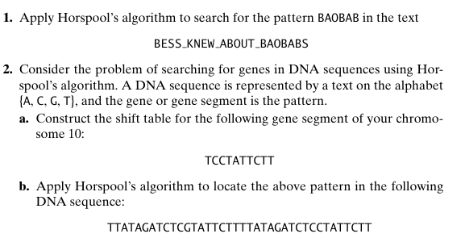
Q3:
